**K-means**

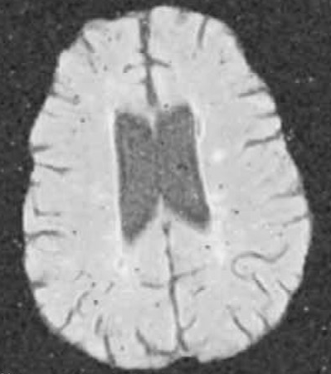 

Number of clusters = 2

VI = 1.0604

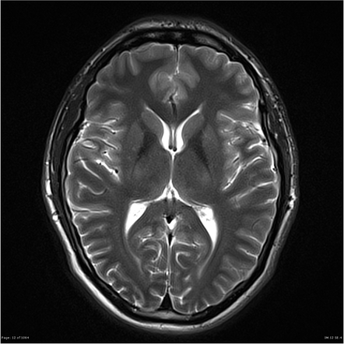 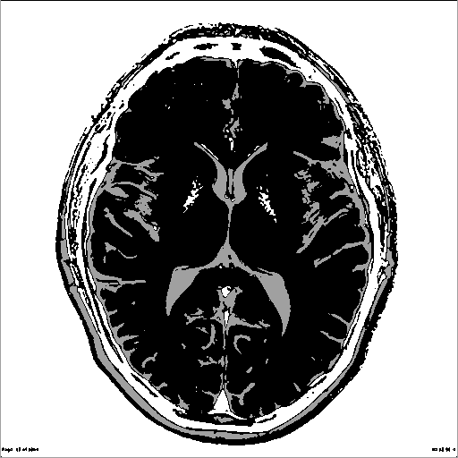

Number of clusters = 3

VI = 1.1407

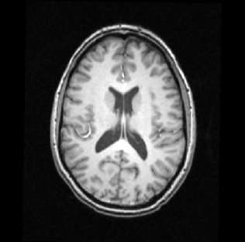 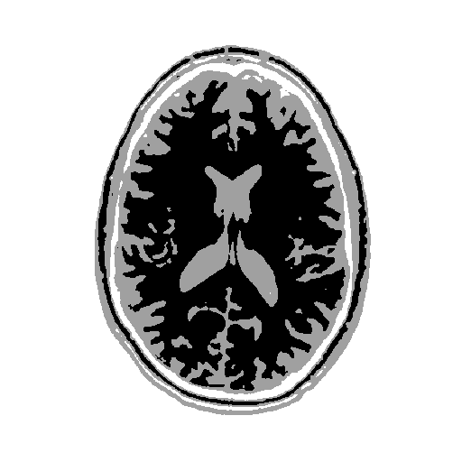

Number of clusters = 3

VI = 1.0529

**SFCM**

 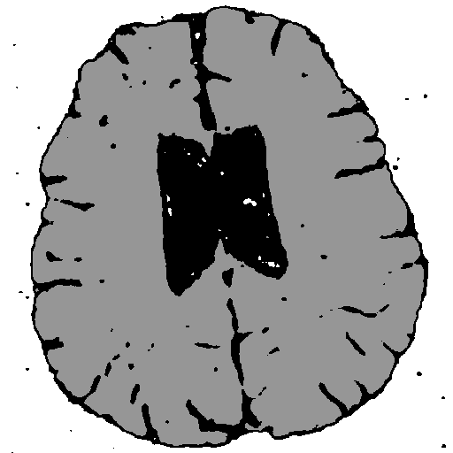

Number of clusters = 3

VI = 0.0592

 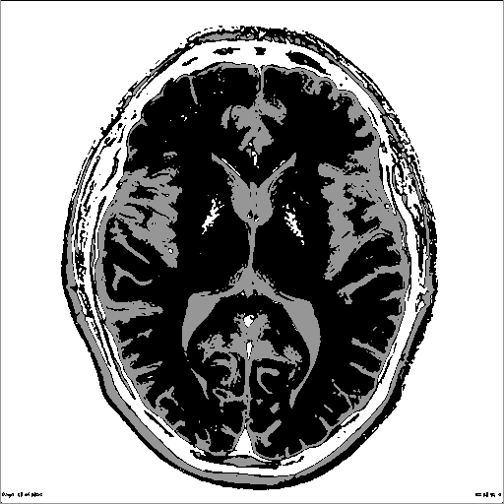

Number of clusters = 3

VI = 0.1131

 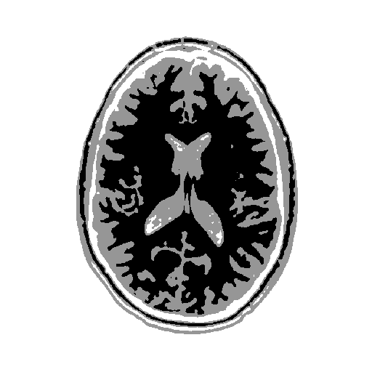

Number of clusters = 3

VI = 0.0625